In no more than ten slides, please address the following prompts based on the data table below.

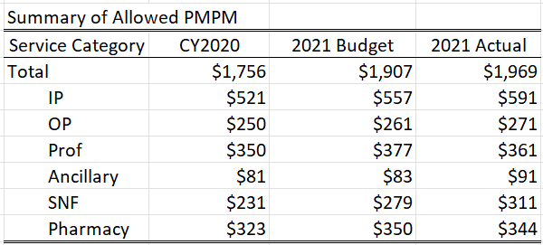

1. Describe the financial condition of the market.
2. Propose data analyses which would explain market trends.
3. Describe data analytics which could be used to drive performance to reduce variances to budget and the upward trajectory of costs going forward.
   1. What approaches do you recommend to improve accuracy of budgeting?
   2. What approaches do you recommend to improve cost performance?
4. Assume you are working on behalf of a provider group.
   1. What are the key structures you would like to see in a value-based contract between a payer and a provider group to address variation in the data?
   2. What actions and changes in care plans would you recommend the provider group employ to address variations in the data?
   3. How would you design a performance plan for a physician with a small panel?
5. Describe the role you need to play with organizational leadership to gain their commitment to actions which will improve overall costs? How do you maintain high credibility with the leadership team?